How to change Wifi connection on Yealink AX83H

- Take your Yealink handset and press the middle ‘OK’ button
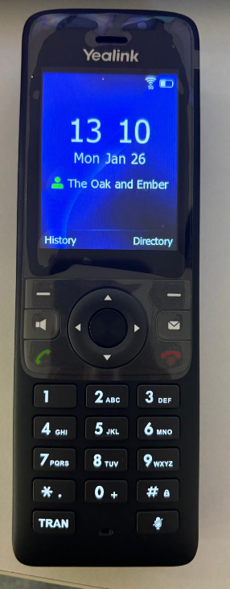

- Navigate to the Wi-Fi settings on the top row 3rd icon from the left.


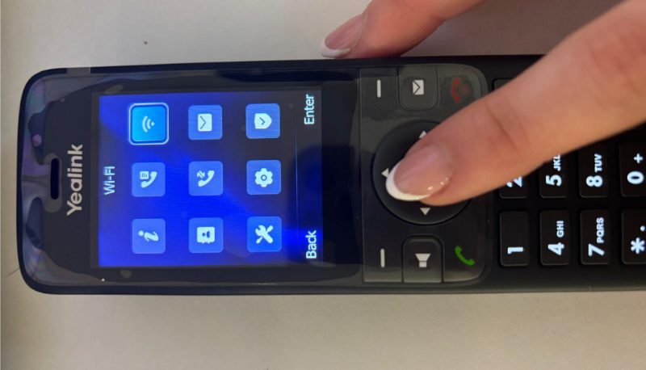

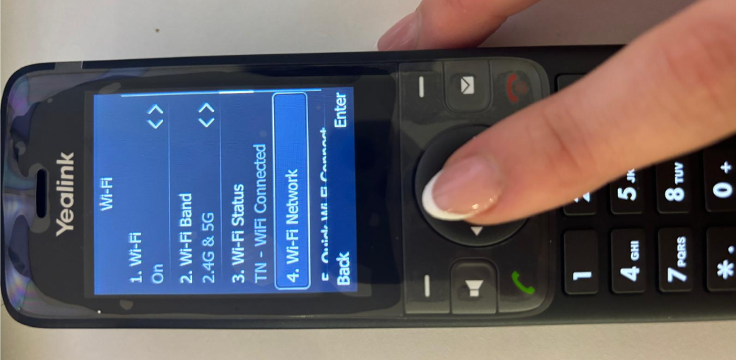
- Scroll Down to Number 4. Wi-Fi Network.

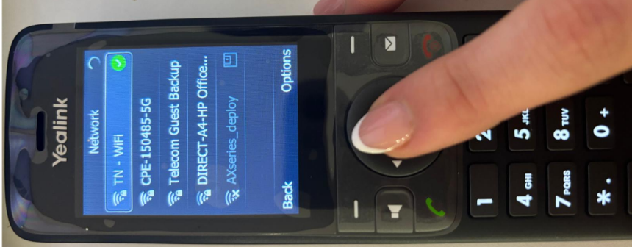
- Select Relevant Wi-Fi Network and use number/letter keys to input Wi-Fi password.

